Company Information

Shri Jagdamba Polymers Limited is an India-based company, engaged in the manufacturing of technical textiles. The Company specializes in textile fabrics impregnated, coated, covered, or laminated with plastic. It is a leading manufacturer in the Technical Textiles Industry, renowned for its innovative solutions and commitment to quality.

Established in 1985, listed on the Bombay Stock Exchange Limited (BSE Limited) in 1986, the Company has grown significantly over the past 4 decades, positioning itself as a key player in the production of a wide range of Technical Textiles.

The Company continues to prioritize quality and innovation while we continue to strive towards delivering superior textile products that meet the diverse needs of our customers. Our extensive range of fabric offerings allows us to cater to various industries and applications. Our commitment to Quality is reflected in our ISO 9001:2015 certification for meeting the worldwide standard that sets requirements for a strong Quality Management System for the manufacturing and supply of HDPE/ PP Woven Fabrics and Bags.

It is also engaged in job work activities, providing customized solutions and services to its clients. More than 80% of production is exported to the United States, UAE, UK, Brazil and several other countries.

The company has global footprints across the following 9 countries:
Brazil, Canada, Morocco, Slovenia, South Africa, ST Kitts, UAE, UK and USA
Mark the following MAP accordingly:
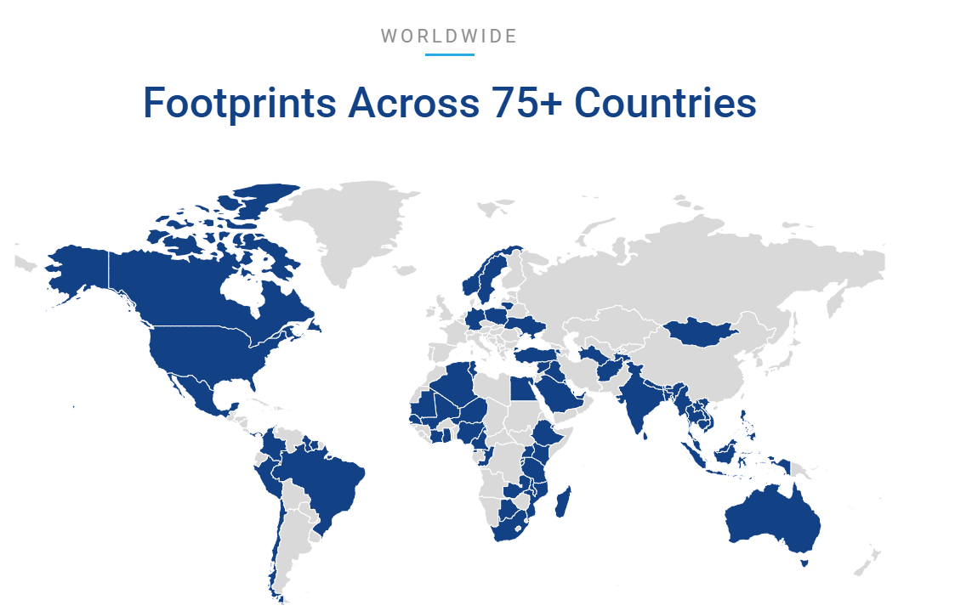

Address  HARMONY, 4th Floor, 15/A, Shree Vidhyanagar Co. Op. Hsg. Soc. Ltd., Opp. NABARD, Nr. Usmanpura Garden, Ahmedabad, Gujarat- 380 014 | Contact Information  +91 (79) 26565792  https://www.shrijagdamba.com/ | Industry  Containers & Packaging

Board of Directors and Key Managerial Personnel

Maheshkumar Gaurishankar Joshi  Chairman and Independent Director | Ramakant Bhojnagarwala  Founder and Managing Director | Kiranbhai Bhailalbhai Patel  Whole- Time Director
Vikas Srikishan Agarwal  Executive Director | Radhadevi Agarwal  Non- Executive Director | Shail Akhil Patel  Independent Director
Hanskumar Agarwal  Chief Executive Officer | Anilkumar Babulal Parmar  Chief Financial Officer | Dharmistha Kabra  Company Secretary and Compliance Officer

